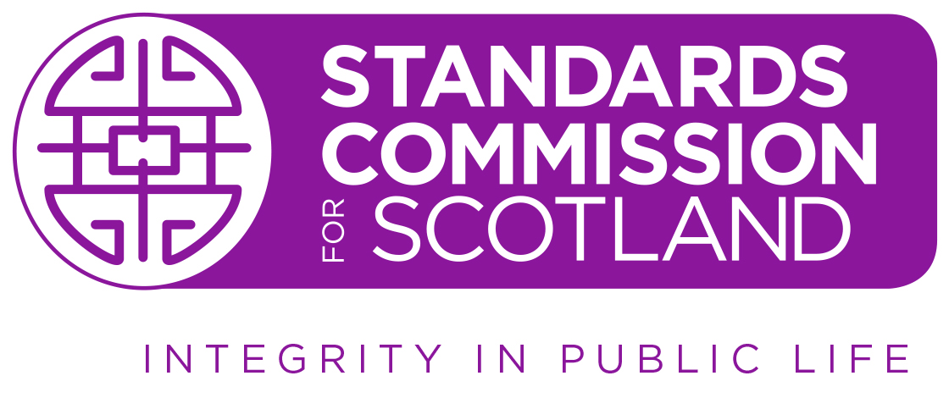

HEARING – Mr Sid Perrie

CHAIR’S OPENING REMARKS

Good morning. Today, the Standards Commission for Scotland is holding a Hearing into an alleged breach of the Code of Conduct for Board Members of Loch Lomond and The Trossachs National Park Authority by Mr Sid Perrie. My name is Morag Ferguson. I am a member of the Standards Commission, and I will chair today’s Hearing Panel.

General information:
- Fire Alarm: no fire alarm tests planned - nearest exit route
- Toilets: location
- Mobile phones – please put on silent or switch off

The Hearing is a formal and ordered process and, therefore, it is very important that we have silence from any members of the public in attendance during the course of the proceedings.

In attendance today:
- On my left is Suzanne Vestri and on my right is Malcolm Bell, who are also members of the Standards Commission.
- Sitting at the table on the Panel’s left is the Ethical Standards Commissioner’s representative, Angela Glen, Senior Investigating Officer.
- Sitting directly to the right of the Panel is Lorna Johnston, Executive Director of the Standards Commission, and Edward Fellows, Case Manager, who will assist during the Hearing.

Section 20 of the Ethical Standards in Public Life etc. (Scotland) Act 2000 requires the Standards Commission to provide the Respondent with written notice of the Hearing. In this case, the Panel has been advised that the Respondent will not be in attendance or represented at the Hearing. It is nevertheless satisfied that he has been provided with notice as required by the Act and, as such, is content to proceed in his absence.

THE COMPLAINT
Having received a complaint about the Respondent, Mr Perrie on 30 August 2024, and having undertaken an investigation, the Ethical Standards Commissioner sent the Standards Commission a report on 17 October 2025. This outlined the Commissioner’s conclusion that the Respondent had breached the Loch Lomond and The Trossachs National Park Authority’s Board Members’ Code of Conduct in respect of emails that he sent in August and September 2024.

It should be noted that, regardless of the conclusions reached by the Commissioner, it is for today’s Panel to make a final decision on whether the Code has been breached and, if so, on what the sanction should be.

I would also note the Panel is only making a determination on whether the Respondent’s conduct, in sending the emails in question, amounted to a breach of the Code. The Panel has no remit whatsoever to make any determination regarding the planning application to which these related, any actions or decisions taken or made by the Park Authority, or the conduct of its employees or any other Board members.

ORDER OF PROCEEDINGS
The Panel notes that no witnesses are to be called to give evidence. In terms of the order of proceedings, I therefore ask Ms Glen to proceed to present the ESC’s case.

The Hearing Panel will then adjourn and determine whether, on the balance of probabilities, a breach of the Code has occurred, and will return and announce its decision in public.

ANY QUESTIONS?
Ms Glen, do you have any questions about the process?

PRESENTATIONS OF CASE
Ms Glen, please proceed to present your findings and submissions as to whether there has been a breach of the Code.

Panel questions for Ms Glen.

FURTHER SUBMISSIONS
I would now like to give Ms Glen the opportunity, should she wish, to make further brief submissions in response to any questions the Panel has asked.

Ms Glen, would you like to take this opportunity?

ADJOURN
The Panel will now adjourn to determine whether or not it is satisfied, on the balance of probabilities, that there has been a breach of the Councillors’ Code of Conduct by the Respondent.

If the Panel decided there has been a breach, it will proceed to determine the sanction to be applied. In doing so, it will consider any mitigation or submissions on sanction previously provided by the Respondent.

We expect to resume at TIME.
NOTE: If this break is intended to be a lunch break, ask the parties whether the proposed break is sufficient.

ANNOUNCING DECISION
Read verbal decision
If no breach that is the end of the proceedings – otherwise:

ANNOUNCING SANCTION DECISION
Read sanction and reasons
If suspension or disqualification, confirm that the date on which the sanction will take effect will be stated in the full written decision, which will be issued within 14 days.

APPEAL PROCEDURE
The procedure for appealing against a decision of the Hearing Panel in relation to the decision of breach [and in relation to sanction], is contained in Section 22 of the Ethical Standards in Public Life, etc. (Scotland) Act 2000.

THAT CONCLUDES TODAY’S HEARING

ADDITIONAL NOTES / SUGGESTED RESPONSES

Conduct of the Complainer
[Insert Name], please note the Panel’s role is to consider the conduct of the Respondent, not the Complainer. The Panel has understood the point you are making so please now move on.

Irrelevant issues
If relevancy unclear:
I’m sorry, but I’m going to interrupt you. The Panel does not understand why [this line of questions / submissions on this point] is relevant. Can you please explain the relevance to the alleged breach of the Code.

If definitely irrelevant:
I’m sorry, but I’m going to stop you. The Panel does not consider that [any answers to these questions / submissions on this point] to be directly relevant or material to the question of the whether the Respondent has breached the Code in respect of the complaint that the Panel is considering. Please move on.

Repetitive / labouring the point
I’m sorry, but I’m going to stop you. The Panel is satisfied that it has heard enough on this point. Please move on.

