Loch Achray

6
Small but very picturesque Loch Achray is reached six miles west of the tourist town of Callander or via the Duke’s Pass heading north from Aberfoyle.
The idyllic location is between two larger lochs, Katrine and Venachar, and at the foot of Ben A’an, where you can start a walk to the 454m summit. The views back down over the still waters on a fine day are breath-taking.
To the south of the loch, large areas of forestry offer tracks and trails for walkers and cyclists.
Thanks to its sheltered location Loch Achray is popular with swimmers and anglers. The loch is home to brown trout as well as pike, perch and salmon.

Loch Achray South / Loch Àth a' Chrathaidh a Deas
This permit area has stunning views of Loch Achray and onto Ben A’an. It’s a fenced grassy area that slopes down to the loch shore where there’s a narrow bank of trees providing some shelter. There is limited parking in the layby by the gate into the field.

Permit areas don't have set pitches; you choose where you want to camp within the area. This permit area has a maximum of 4 spaces available. The terrain at Loch Achray South is grassy field. Click on the thumbnails below for a map of the area.

Getting there:
The permit area is accessed directly off the A821, at the north end of the Duke’s Pass.
Grid reference:
NN508063
View in Google maps:
https://goo.gl/KFdHgB
Grade & terrain:
Easy. Access to the permit area is through a metal kissing gate at the layby then through a gate in the permit area fence onto gently inclined pasture land down to the shore.
Toilets nearby:
There are public toilets located about 2.5km away at the Trossachs Pier, Loch Katrine (5 minutes’ drive by car).
Drinking water available:
No
Parking facilities nearby:
Limited parking in the layby adjacent to the area.
Fishing permit information:
available at www.lochlomond-trossachs.org/angling
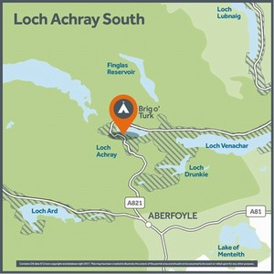

8
Availability has been found for the dates you have entered and is highlighted below. We have also found some other dates that you may wish to consider. Click on your preferred option to continue.
Sun 1 Mar | 1 Night  £3.00  4 remaining | 2 Nights  £6.00  4 remaining
Mon 2 Mar | 1 Night  £3.00  4 remaining | 2 Nights  £6.00  4 remaining

Loch Earn

1
Loch Earn is a long, narrow stretch of water located in the north east of the National Park. Extending 6.5 miles from west to east, the loch is the source of the River Earn, which eventually winds its way to join the River Tay, Scotland’s longest river, in the Perthshire village of Bridge of Earn.
There are several farms and houses dotted along the lochside, including the villages of St Fillans, at its most easterly tip, and Lochearnhead to the west.
An innovative trail called BLiSS links four locations on the loch and nearby, Balquhidder, Lochearnhead, Strathyre and St Fillans, and features a series of art and ornamental installations.

North Shore A / Cladach a Tuath Loch Èire A
The Loch Earn North Shore Permit areas are in a series of long laybys off of the A85 and they run from west to east, with permit area A the further west and area D furthest east. All four areas offer the opportunity to camp along the lochshore with uninterrupted views up and down Loch Earn and over to the imposing Ben Vorlich.

Permit areas don't have set pitches; you choose where you want to camp within the area. This permit area has a maximum of 4 spaces available. Permit Area A includes a pebble beach, a grassy bank, and there's a small line of trees separating the shore from the layby. The terrain you can choose from for camping includes the grassy area next to the layby or the beach. The pebbles on the beach are deep so long tent pegs are helpful. Click on the thumbnails below the map for photos of the area.

Getting there:
The permit area is located adjacent to an existing horseshoe shaped layby, approximately 5km east of Lochearnhead along the A85.
Grid reference:
NN641242
View in Google maps:
https://goo.gl/kXjdaF
Grade & terrain:
Easy. This permit area is reached from a layby with relatively level access to the lochshore.
Toilets nearby:
There are public toilets located at St. Fillans, around 4.5km away.
Drinking water available:
No
Parking facilities nearby:
Some parking available in the adjacent layby, but this is not guaranteed.
Fishing permit information:
Loch Earn is popular for fishing and you will need a fishing permit, in addition to your camping permit, to fish in the loch. Fishing permit information is available at www.lochlomond-trossachs.org/angling
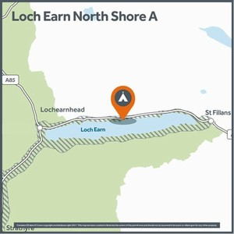

10
Availability has been found for the dates you have entered and is highlighted below. We have also found some other dates that you may wish to consider. Click on your preferred option to continue.
Sun 1 Mar | 1 Night  £3.00  4 remaining | 2 Nights  £6.00  4 remaining
Mon 2 Mar | 1 Night  £3.00  4 remaining | 2 Nights  £6.00  4 remaining

North Shore B / Cladach a Tuath Loch Èire B
The Loch Earn North Shore Permit areas are in a series of long laybys off of the A85 and they run from west to east, with permit area A the furthest west and area D furthest east. All four areas offer the opportunity to camp along the lochshore with uninterrupted views up and down Loch Earn and over to the imposing Ben Vorlich.

Permit areas don't have set pitches; you choose where you want to camp within the area. This permit area has a maximum of 4 spaces available. Loch Earn North Shore B includes a pebble and stone beach with a bank of trees separating the shore from the layby and a few small grassy areas between trees. The terrain you can choose from for camping includes the grassy spots and the beach. Due to the spacing of trees along the shore, smaller 1-4 person tents are suggested. The pebbles on the beach are deep in places so long tent pegs may be helpful. Click on the thumbnails below the map for photos of the area.

Getting there:
The permit area is located adjacent to an existing horseshoe shaped layby, approximately 5.5km east of Lochearnhead, on the A85.
Grid reference:
NN646243
View in Google maps:
https://goo.gl/NFKxvA
Grade & terrain:
Easy. This permit area is reached from a layby and parking area with relatively level access to the lochshore.
Toilets nearby:
There are public toilets at Lochearnhead and St. Fillans, around 5km away.
Drinking water available:
No
Parking facilities nearby:
Some parking available in the adjacent layby, but this is not guaranteed.
Fishing permit information:
Loch Earn is popular for fishing and you will need a fishing permit, in addition to your camping permit, to fish in the loch. Fishing permit information is available at www.lochlomond-trossachs.org/angling
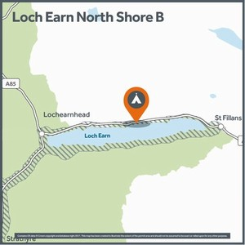

9
Availability has been found for the dates you have entered and is highlighted below. We have also found some other dates that you may wish to consider. Click on your preferred option to continue.
Sun 1 Mar | 1 Night  £3.00  4 remaining | 2 Nights  £6.00  4 remaining
Mon 2 Mar | 1 Night  £3.00  4 remaining | 2 Nights  £6.00  4 remaining

North Shore C / Cladach a Tuath Loch Èire C
The Loch Earn North Shore Permit areas are in a series of long laybys off of the A85 and they run from west to east, with permit area A the furthest west and area D furthest east. All four areas offer the opportunity to camp along the lochshore with uninterrupted views up and down Loch Earn and over to the imposing Ben Vorlich.

Permit areas don't have set pitches; you choose where you want to camp within the area. This permit area has a maximum of 5 spaces available. Loch Earn North Shore C is reached from a layby with relatively level access to the lochshore. The area includes a pebble and stone beach with a bank of trees separating the shore from the layby and a few small grassy areas between trees. Due to the spacing of trees in some areas, smaller 1-3 person tents are suggested, the more exposed pebble areas could take larger tents. The pebbles on the beach are deep in places so long tent pegs may be helpful. Click on the thumbnails below the map for photos of the area.

Getting there:
The permit area is located adjacent to an existing horseshoe shaped layby, approximately 6.5km east of Lochearnhead, on the A85.
Grid reference:
NN651243
View in Google maps:
https://goo.gl/ehM4kh
Grade & terrain:
Moderate. The permit area is reached from a layby with a small steep incline down to the lochshore.
Toilets nearby:
There are public toilets at Lochearnhead (6.5km) and St. Fillans (3.5km).
Drinking water available:
No
Parking facilities nearby:
There is some parking available within the existing layby, but this is not guaranteed.
Fishing permit information:
Loch Earn is popular for fishing and you will need a fishing permit, in addition to your camping permit, to fish in the loch. Fishing permit information is available at www.lochlomond-trossachs.org/angling
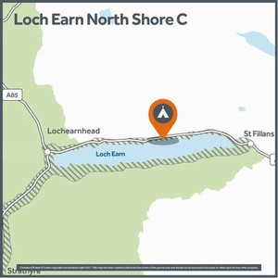

12
Availability has been found for the dates you have entered and is highlighted below. We have also found some other dates that you may wish to consider. Click on your preferred option to continue.
Sun 1 Mar | 1 Night  £3.00  5 remaining | 2 Nights  £6.00  5 remaining
Mon 2 Mar | 1 Night  £3.00  5 remaining | 2 Nights  £6.00  5 remaining

North Shore D / Cladach a Tuath Loch Èire D
The Loch Earn North Shore Permit areas are in a series of long laybys off of the A85 and they run from west to east, with permit area A the furthest west and area D furthest east. All four areas offer the opportunity to camp along the lochshore with uninterrupted views up and down Loch Earn and over to the imposing Ben Vorlich.

Permit areas don't have set pitches; you choose where you want to camp within the area. This permit area has a maximum of 20 spaces available. Loch Earn North Shore D is reached from a long layby with access down a bank to the lochshore. The area includes a pebble beach with trees separating the shore from the layby. The boundaries are marked by permit area signs at each end of the shore, and there is a sign with a map in the layby. The terrain for camping is pebble beach so long tent pegs may be helpful. Due to the spacing of trees and boulders, smaller 1-3 person tents are suggested. Click on the thumbnails below the map for photos of the area.

Getting there:
The permit area is located adjacent to an existing horseshoe shaped layby, approximately 7km east of Lochearnhead, on the A85.
Grid reference:
NN659244
View in Google maps:
https://goo.gl/TpPn9R
Grade & terrain:
Moderate. It is reached from a layby and parking area with a small steep incline down to the lochshore.
Toilets nearby:
There are public toilets at Lochearnhead (7km) and St. Fillans (2.5km).
Drinking water available:
No
Parking facilities nearby:
There is some parking available within the existing parking area, but this is not guaranteed.
Fishing permit information:
Loch Earn is popular for fishing and you will need a fishing permit, in addition to your camping permit, to fish in the loch. Fishing permit information is available at www.lochlomond-trossachs.org/angling
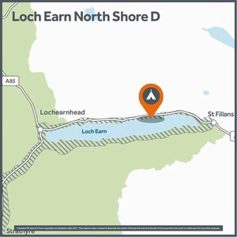

12
Availability has been found for the dates you have entered and is highlighted below. We have also found some other dates that you may wish to consider. Click on your preferred option to continue.
Sun 1 Mar | 1 Night  £3.00  20 remaining | 2 Nights  £6.00  20 remaining
Mon 2 Mar | 1 Night  £3.00  20 remaining | 2 Nights  £6.00  20 remaining

South Shore A / Loch Èire a Deas A
This permit area is accessed via a steep, grassy, wooded hillside that goes down to a narrow pebble beach with uninterrupted views up and down Loch Earn and north over to Sron Mhor. Please note that you will need to carry your camping equipment down a steep slope for a few minutes to reach the good areas for camping near the shore.

Permit areas don't have set pitches; you choose where you want to camp within the area. This permit area has a maximum of 7 spaces available. The terrain you have to choose from for camping is some flat grassy areas in between trees or on the narrow pebble beach – so best suited to smaller 1-4 person tents. The pebbles on the beach are deep in places so long tent pegs may be helpful. Click on the thumbnails below the map for photos of the area.

Getting there:
Coming from St Fillans, the permit area is just after the Loch Earn Caravan Park, approximately 2km west of St. Fillans.
Grid reference:
NN672237
View in Google maps:
https://goo.gl/Scu5M6
Grade & terrain:
Strenuous. Access is along informal paths down a steep embankment.
Toilets nearby:
There are public toilets located at St. Fillans, around 4.3km away.
Drinking water available:
No
Parking facilities nearby:
Very limited parking places along the road. Parking is prohibited in passing places.
Fishing permit information:
Loch Earn is popular for fishing and you will need a fishing permit, in addition to your camping permit, to fish in the loch. Fishing permit information is available at www.lochlomond-trossachs.org/angling
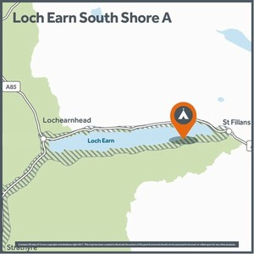

10
Availability has been found for the dates you have entered and is highlighted below. We have also found some other dates that you may wish to consider. Click on your preferred option to continue.
Sun 1 Mar | 1 Night  £3.00  7 remaining | 2 Nights  £6.00  7 remaining
Mon 2 Mar | 1 Night  £3.00  7 remaining | 2 Nights  £6.00  7 remaining

South Shore B / Loch Èire a Deas B
This is a long permit area that runs for about 4 kilometres along a narrow strip of land between the road and the Loch Earn shore and it has uninterrupted views of the loch and north over to Sron Mhor.

Permit areas don't have set pitches; you choose where you want to camp within the area. This permit area has a maximum of 40 spaces available. The terrain you can choose from varies along the shore. In some places there is a grassy slope or bank, in others there is pebble beach. There are trees and boulders along the shoreline so most areas are best suited to smaller 1-4 person tents. The pebbles on the beach are deep in places so long tent pegs may be helpful. Click on the thumbnails below the map for photos of the area.

Getting there:
The permit area is located approximately 3km west of St. Fillans.
Grid reference:
NN 644 231
View in Google maps:
https://goo.gl/z1V5m0
Grade & terrain:
Can be strenuous. Access is along informal paths down steep embankment in some places. Other locations are easy to access.
Toilets nearby:
There are public toilets located at St. Fillans, around 5.5 km away.
Drinking water available:
No
Parking facilities nearby:
Very limited parking places along the road. Parking is prohibited in passing places.
Fishing permit information:
Loch Earn is popular for fishing and you will need a fishing permit, in addition to your camping permit, to fish in the loch. Fishing permit information is available at www.lochlomond-trossachs.org/angling
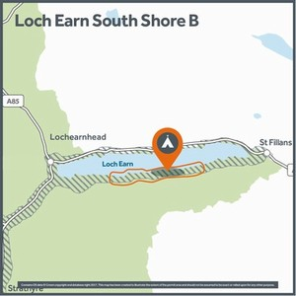

15
Availability has been found for the dates you have entered and is highlighted below. We have also found some other dates that you may wish to consider. Click on your preferred option to continue.
Sun 1 Mar | 1 Night  £3.00  40 remaining | 2 Nights  £6.00  40 remaining
Mon 2 Mar | 1 Night  £3.00  40 remaining | 2 Nights  £6.00  40 remaining

Loch Lomond

1
The largest inland stretch of water in Britain, Loch Lomond is one of the most popular destinations in Scotland.
The main A82 road offers easy access to villages and viewpoints along the west side of the loch, such as Luss, Arden, Firkin Point and Tarbet. Hugging the same shoreline, from Balloch to Tarbet, is a traffic-free cycle route, the West Loch Lomond Cycle Path.

Culag (beach) / Cùileag
This permit area is on a strip of shingle shoreline with stunning views up and down Loch Lomond as well as east over to Ben Lomond.

Permit areas don't have set pitches; you choose where you want to camp within the area. This permit area has a maximum of 4 spaces available. The terrain at Culag is a narrow shingle beach with some boulders and trees and is best suited to small tents. Please note that the permit area consists of the beach only, not the woodland above it or around the parking area. There are boundary markers at either end of the beach and you can choose where to camp in between them. Click on the thumbnails below the map for photos of the area.

Getting there:
Located approximately 4km north of Luss village off the A82 and accessible from the West Loch Lomond Cycle Path. Please note that the area is only accessible for southbound traffic. If you are on the northbound carriageway do not turn into the layby. Please ensure you find a safe place further up the road to turn onto the southbound carriageway and then enter the layby.
Grid reference:
NS352955
View in Google maps:
https://goo.gl/pNnZZb
Grade & terrain:
Moderate. The permit area is reached via a short steep track leading to the shoreline from a south bound layby along the A82.
Toilets nearby:
No.
Drinking water available:
No.
Parking facilities nearby:
There is limited parking within the adjacent parking area off the layby.
Fishing permit information:
Available at www.lochlomond-trossachs.org/angling
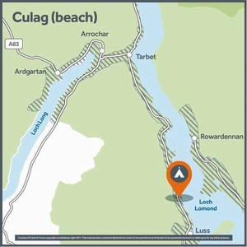

11
Availability has been found for the dates you have entered and is highlighted below. We have also found some other dates that you may wish to consider. Click on your preferred option to continue.
Sun 1 Mar | 1 Night  £3.00  4 remaining | 2 Nights  £6.00  4 remaining
Mon 2 Mar | 1 Night  £3.00  4 remaining | 2 Nights  £6.00  4 remaining

Inveruglas / Inbhir Dhubhghlais
Inveruglas camping permit area sits along the wooded banks of Loch Lomond with great views across the loch to Ben Lomond. This permit area is part of a busy destination for visitors, coaches and loch cruises. There are toilets that are open during the day (March to October), and you can visit the Scottish Scenic Routes viewpoint, An Ceann Mòr, an 8m high wooden pyramid structure that provides elevated panoramic views over Loch Lomond. The camping permit area is situated away from the visitor centre, along the loch shore. There is also a permit area for motorhomes.

Permit areas don't have set pitches; you choose where you want to camp within the area. This permit area has a maximum of 5 spaces available. Inveruglas permit area stretches from the back of the Long Stay Car Park to the shoreline, with the best spots for camping along the shore. The terrain for camping is a mix of a sand and pebble beach or grassy areas in the trees. The permit area is not suitable for large house tents. Remember! This permit area is close to deep and cold water. Please take care and read our guide on staying safe in the water: https://goo.gl/ktTiXE Click on the thumbnails below the map for photos of the area.

Getting there:
The area is accessed directly off the A82, opposite the Loch Sloy power station.
Grid reference:
NN323099
View in Google maps:
https://goo.gl/pyFZe3
Grade & terrain:
Easy. Access to the permit area is via a relatively flat network of existing formal and informal paths directly from the car park.
Toilets nearby:
Toilets: Yes. They are open 9am – 5pm 1 March – 31 October and closed 1 November – 28 February. Please note that motorhome chemical toilets cannot be emptied at Inveruglas.
Drinking water available:
No.
Parking facilities nearby:
Ample parking on site.
Fishing permit information:
Available at www.lochlomond-trossachs.org/angling
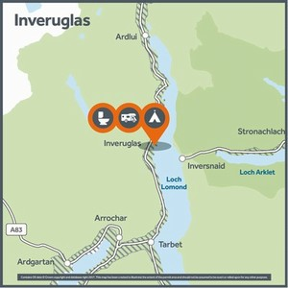

15
Availability has been found for the dates you have entered and is highlighted below. We have also found some other dates that you may wish to consider. Click on your preferred option to continue.
Sun 1 Mar | 1 Night  £3.00  5 remaining | 2 Nights  £6.00  5 remaining
Mon 2 Mar | 1 Night  £3.00  5 remaining | 2 Nights  £6.00  5 remaining

Lochan Maoil Dhuinne
This permit area is best suited to those walking the West Highland Way, as it lies off the path on the eastern banks of Loch Lomond, about 10km from Balmaha to the south, or 1.5km from Rowardennan to the north.

Permit areas don't have set pitches; you choose where you want to camp within the area. This permit area has a maximum of 5 spaces available. In this area you can camp in the trees, if you'd like to be a bit more sheltered, or along the pebbly beaches with stunning views across the loch on both sides. The permit area is most suited to smaller 2-3 person tents, however if you'd like to come with friends, this permit area would allow you to camp alongside each other on the beach areas. Click on the thumbnails below the map for photos of the area.

Getting there:
The permit area can only be accessed from the West Highland Way footpath leading out of Balmaha northwards (approx. 9.5km) or heading south from Rowardennan (approx. 1.5km). The C6 road runs parallel with Loch Lomond out of Balmaha, and although limited access can be gained from the roadside, the road itself is a designated clearway so parking is not allowed.
Grid reference:
NS360976 (NS 361976)
View in Google maps:
https://goo.gl/P1JZSw
Grade & terrain:
Moderate. The ground is soft and uneven, with some shallow inclines.
Toilets nearby:
No. The nearest toilets are at Rowardennan, around 1.5km away.
Drinking water available:
No. Drinking water is available at Rowardennan, around 1.5km away.
Parking facilities nearby:
Parking is only available at Rowardennan or Balmaha and there is no parking at the permit area. Please note Rowardennan is a pay and display car park.
Fishing permit information:
Available at www.lochlomond-trossachs.org/angling
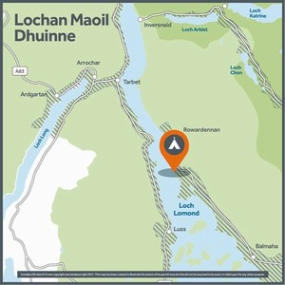

11
Availability has been found for the dates you have entered and is highlighted below. We have also found some other dates that you may wish to consider. Click on your preferred option to continue.
Sun 1 Mar | 1 Night  £3.00  4 remaining | 2 Nights  £6.00  4 remaining
Mon 2 Mar | 1 Night  £3.00  5 remaining | 2 Nights  £6.00  4 remaining

Suie field / An Suidhe
This permit area includes a long pebble beach, open field and sheltered wood and lies on the shore of Loch Lomond with open views of the loch and Ben Lomond.

Permit areas don't have set pitches; you choose where you want to camp within the area. This permit area has a maximum of 4 spaces available. Suie Field offers a variety of terrain to camp on from a wide pebble beach and open grassy areas that are suited to any size of tent, to spots in the trees on the lochshore that would suit a small 1 or 2 person tent. Click on the thumbnails below the map for photos of the area.

Getting there:
This area is approximately 3km north of Luss village on the A82 and is accessible from the West Loch Lomond Cycle Path. Please note that the area is only accessible for southbound traffic. If you are on the northbound carriageway do not turn into the layby. Please ensure you find a safe place further up the road to turn onto the southbound carriageway and then enter the layby.
Grid reference:
NS348970
View in Google maps:
https://goo.gl/ohTqpC
Grade & terrain:
Moderate. Access to the permit area is down a small steep slope to the shoreline.
Toilets nearby:
No
Drinking water available:
No
Parking facilities nearby:
There is very limited parking within the adjacent layby.
Fishing permit information:
Available at www.lochlomond-trossachs.org/angling
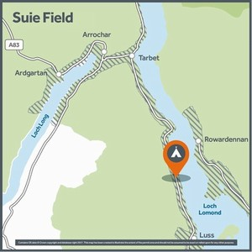

14
Availability has been found for the dates you have entered and is highlighted below. We have also found some other dates that you may wish to consider. Click on your preferred option to continue.
Sun 1 Mar | 1 Night  £3.00  4 remaining | 2 Nights  £6.00  4 remaining
Mon 2 Mar | 1 Night  £3.00  4 remaining | 2 Nights  £6.00  4 remaining

Tarbet Isle / An Tairbeart
This permit area sits on a hillside of mature woodland with views through the trees south over Loch Lomond and is reached by a forestry path running in a short loop from the Tarbet Isle car park. The permit area is on a hill so you need to walk about 5-10 minutes up the path to find the flatter areas that are good for camping.

Permit areas don't have set pitches; you choose where you want to camp within the area. This permit area has a maximum of 3 spaces available. The terrain here is grassy, mossy forest floor with small clearings between the trees which would be suited to camping with 1-3 person tents. This area is also good for hammock camping. Click on the thumbnails below the map for photos of the area.

Getting there:
The area is accessed directly from the small Tarbet Isle car park, off the A82, just north of Tarbet. If you're thinking of walking to the car park, please be careful as there is no pavement along the edge of the A82.
Grid reference:
NN326054
View in Google maps:
https://goo.gl/cyb0KR
Grade & terrain:
Moderate. Access is via an initially steep gravel path, which then levels out.
Toilets nearby:
No.
Drinking water available:
No.
Parking facilities nearby:
Limited parking available within the Tarbet Isle car park.
Fishing permit information:
Available at www.lochlomond-trossachs.org/angling
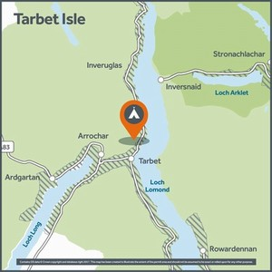

8
Availability has been found for the dates you have entered and is highlighted below. We have also found some other dates that you may wish to consider. Click on your preferred option to continue.
Sun 1 Mar | 1 Night  £3.00  3 remaining | 2 Nights  £6.00  3 remaining
Mon 2 Mar | 1 Night  £3.00  3 remaining | 2 Nights  £6.00  3 remaining

Loch Long

1
Loch Long is a sea loch extending 20 miles from the Firth of Clyde at its southwestern end. Similar to a fjord, the loch forms a long indent with the coast of the Cowal Peninsula on one side and the entire western coastline of the Rosneath Peninsula on the other side.
At the foot of the loch on the east shore is the Rosneath village of Cove, while at the head is the village of Arrochar. The stunning high-rise Arrochar Alps offer many attractions for walkers, with The Cobbler (Ben Arthur) and the Munros of Beinn Narnain and Beinn Ime offering summit goals.

Coilessan / An Caol-Easan
This permit area is popular with anglers and sits within woodland at the base of a steep hillside. There are some lovely flat loch shore areas to camp with stunning views out over Loch Long.

Permit areas don't have set pitches; you choose where you want to camp within the area. This permit area has a maximum of 6 spaces available. The terrain at Coilessan offers you two options of where to camp: there are some small flat areas higher up the slope that would suit 1-2 person tents. But many of the best areas for camping are down along the shoreline, on grassy or leaf covered ground in between the trees. Some areas could accommodate a 4-5 person tent, but smaller tents are advised to fit between the trees and because you need to carry your equipment down a steep slope. This would also be a good location for hammock camping. Click on the thumbnails below the map for photos of the area.

Getting there:
The permit area is 2km down a forestry road, which is accessed directly off the Ardgartan Visitor Centre car park, on the A83.
Grid reference:
NN267016
View in Google maps:
https://goo.gl/vttgar
Grade & terrain:
Strenuous. The area is reached via a very steep embankment leading down to the loch’s edge. The ground is unstable in places.
Toilets nearby:
There are public toilets at the Ardgartan Visitor Centre, at the entrance to the forestry road, approximately 2km away.
Drinking water available:
No
Parking facilities nearby:
Limited parking adjacent to the site
Fishing permit information:
Available at www.lochlomond-trossachs.org/angling
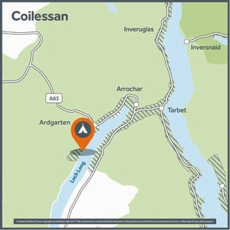

11
Availability has been found for the dates you have entered and is highlighted below. We have also found some other dates that you may wish to consider. Click on your preferred option to continue.
Sun 1 Mar | 1 Night  £3.00  6 remaining | 2 Nights  £6.00  6 remaining
Mon 2 Mar | 1 Night  £3.00  6 remaining | 2 Nights  £6.00  6 remaining

Falls of Leny

1
The Falls of Leny are a series of waterfalls on the River Leny, south of Loch Lubnaig.
Loch Lubnaig is a small but stunningly located stretch of freshwater nestling between two striking mountains, Ben Ledi and Benvane to the south-west and Ben Vorlich to the north-east. A bird’s eye view of the loch (or take a look on a map), reveals how it came by its name, Lùbnaig, which means crooked in Gaelic.
The A84 runs along the eastern side of the loch, which makes access very easy, whether by car or bike. If you prefer your cycling to be a little quieter, a section of the National Cycle Network's Route 7 runs along the west shore on the route of the former Callander and Oban Railway. The nine-mile trail, between Callander and Strathyre, is a scenic bike ride or a walk.

Falls of Leny / EasLànaidh
This permit area is a mix of wooded and open areas south of Loch Lubnaig, accessed directly from the visitor parking area and providing views across to the River Leny. It is set at the foot of the hills to the west of Callander. A connecting local path network provides lots of opportunities to explore the surrounding area.

Permit areas don't have set pitches; you choose where you want to camp within the area. This permit area has a maximum of 4 spaces available. The terrain offers you a few options for choosing where to camp. To either side of the car park are areas of open, level ground on a hard surface which can accommodate both small and 4-5 person tents. To the rear of the area is woodland with softer, leaf covered ground. Small tents can be pitched between the trees and this area would also be suitable for hammock camping. Click on the thumbnails below the map for photos of the area.

Getting there:
The permit area can be reached from the Falls of Leny car park on the A84 approximately 4km west of Callander. If you're thinking of walking to the car park, please be careful as there is no pavement along the edge of the A84.
Grid reference:
NN595090
View in Google maps:
https://goo.gl/84Fksz
Grade & terrain:
Easy to moderate. The woodland to the rear of the permit area requires a short walk uphill on uneven ground.
Toilets nearby:
The nearest public toilets are in Callander, approximately 4km away.
Drinking water available:
No
Parking facilities nearby:
Limited parking within the area itself
Fishing permit information:
Available at www.lochlomond-trossachs.org/angling
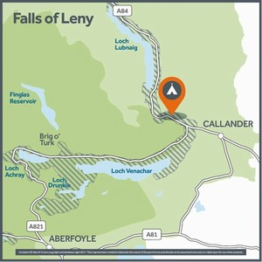

10
Availability has been found for the dates you have entered and is highlighted below. We have also found some other dates that you may wish to consider. Click on your preferred option to continue.
Sun 1 Mar | 1 Night  £3.00  4 remaining | 2 Nights  £6.00  4 remaining
Mon 2 Mar | 1 Night  £3.00  4 remaining | 2 Nights  £6.00  4 remaining

Loch Venachar

1
Loch Venachar lies between the popular tourist town of Callander and the small settlement of Brig o' Turk. The south shore of the 3.7 mile long loch comprises a large area of forest, which is home to a wide network of cycling and walking trails. A walk of 4.5 miles reveals a hidden lochan amid the trees.
You can follow some trails over the hills to nearby Lake of Menteith– Scotland’s only lake – or head west along the loch to Loch Achray and the Trossachs. Permit areas to the south are accessible from the National Cycle Network 7.

Loch Venachar North Shore B / Cladach a Tuath Loch Bheannachair B
With beautiful views up and down Loch Venachar and south over to the Menteith Hills, this permit area runs along the shoreline. You can reach the permit area either from Aberfoyle in the west or Callander to the east. There are two car parks, one in the middle of the permit area and a larger one at the western end, this is also a day visitor spot with picnic tables.

Permit areas don't have set pitches; you choose where you want to camp within the area. This permit area has a maximum of 6 spaces available. To choose your camping spot follow the footpaths along the shoreline from the car parks. The terrain you can choose from is either pebble and stone beach in trees right on the water’s edge, or further into the woodland on grassy and mossy ground. Much of this area is suited to smaller 1-3 person tents, because of the trees, although there are a few spots that could fit 4-5 person tents. This area is also suitable for hammock camping. Click on the thumbnails below the map for photos of the area.

Getting there:
The permit area starts 500m from the Harbour Cafe, approximately 7.5km west of Callander on the A821.
Grid reference:
NN563061
View in Google maps:
https://goo.gl/NFKxvA
Grade & terrain:
Moderate. Access is along a small, and at times challenging, informal path along the loch shore.
Toilets nearby:
The nearest public toilets are in Callander 7.5km away.
Drinking water available:
No
Parking facilities nearby:
Limited parking available in the National Park car parks.
Fishing permit information:
Available at www.lochlomond-trossachs.org/angling
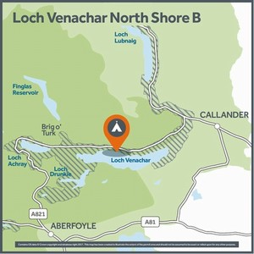

13
Availability has been found for the dates you have entered and is highlighted below. We have also found some other dates that you may wish to consider. Click on your preferred option to continue.
Sun 1 Mar | 1 Night  £3.00  6 remaining | 2 Nights  £6.00  6 remaining
Mon 2 Mar | 1 Night  £3.00  6 remaining | 2 Nights  £6.00  6 remaining

Loch Venachar South Shore / Cladach a Deas Loch Bheannachair
This permit area offers great views up and down Loch Venachar and north over to Stuc Odhar and the distant Ben Ledi. It follows a narrow strip of land between a single track road and the lochshore for approximately 250 metres and is relatively exposed with trees separating the shore from the road.

Permit areas don't have set pitches; you choose where you want to camp within the area. This permit area has a maximum of 6 spaces available. The terrain you can choose from for camping is a mix of pebble, gravel and small grassy areas. There are trees and boulders along the shoreline so most areas are best suited to smaller 1-4 person tents. Click on the thumbnails below the map for photos of the area.

Getting there:
The permit area starts approximately 4km south west of Callander, along Invertrossachs Road/NCR 7.
Grid reference:
NN597058
View in Google maps:
https://goo.gl/5z4Kp8
Grade & terrain:
Easy. Access is directly off the Invertrossachs road/NCR7.
Toilets nearby:
The nearest public toilets are in Callander 4km away.
Drinking water available:
No
Parking facilities nearby:
Limited parking available at two nearby car parks, approximately 500m away.
Fishing permit information:
Available at www.lochlomond-trossachs.org/angling
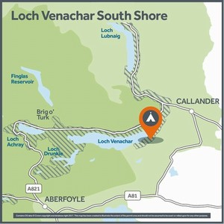

8
Availability has been found for the dates you have entered and is highlighted below. We have also found some other dates that you may wish to consider. Click on your preferred option to continue.
Sun 1 Mar | 1 Night  £3.00  6 remaining | 2 Nights  £6.00  6 remaining
Mon 2 Mar | 1 Night  £3.00  6 remaining | 2 Nights  £6.00  6 remaining

Loch Voil

1
Loch Voil and its western neighbour, the smaller Loch Doine, lie in a beautiful glen steeped in history. This is part of the area known as Rob Roy country and there are a number of historical highlights relating to the infamous 17th century Scottish outlaw Rob Roy Macgregor. Rob Roy is a Scottish folk hero who became famous through Sir Walter Scott’s novel about his life.
In Balquhidder village, at the eastern end of Loch Voil, you can visit the Old Kirk and the grave of Rob Roy. A viewpoint above the church, called the McLaren Stone, offers a panoramic view over Balquhidder Glen and along the full length of Loch Voil.

Balquhidder Glen / Gleann Bhoth Chuidir
With uninterrupted views up and down Loch Voil and south over to Creag Mhor, this lochshore location is relatively exposed with a small bank of trees separating it from the road. Due to its location on a single-track road, there is very limited parking, it is most suited to those arriving on foot or by bike.

Permit areas don't have set pitches; you choose where you want to camp within the area. This permit area has a maximum of 8 spaces available. The terrain you can choose from varies along the shore, in some places there is a grassy slope or bank, in others there is grass and pebble beach. There are trees and boulders along much of the shoreline so some areas are best suited to smaller 1-4 person tents. The pebbles on the beach are deep in places so long tent pegs may be helpful. Click on the thumbnails below the map for photos of the area.

Getting there:
The permit area is located along the north shoreline of Loch Voil, approximately 4km west of Balquhidder.
Grid reference:
NN489198
View in Google maps:
https://goo.gl/j2p3Cs
Grade & terrain:
Moderate. There is a small, steep embankment leading down to the lochshore.
Toilets nearby:
No
Drinking water available:
No
Parking facilities nearby:
Very limited parking on site. Parking is prohibited within passing places.
Fishing permit information:
Available at www.lochlomond-trossachs.org/angling (please note that fishing is only permitted on the south shore of the loch)
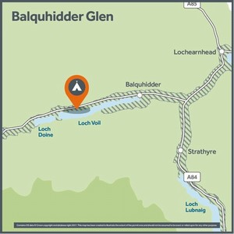

14
Availability has been found for the dates you have entered and is highlighted below. We have also found some other dates that you may wish to consider. Click on your preferred option to continue.
Sun 1 Mar | 1 Night  £3.00  8 remaining | 2 Nights  £6.00  8 remaining
Mon 2 Mar | 1 Night  £3.00  8 remaining | 2 Nights  £6.00  8 remaining

