FIRST LOOK AT VISION FOR £30M LOMOND BANKS HOLIDAY DESTINATION

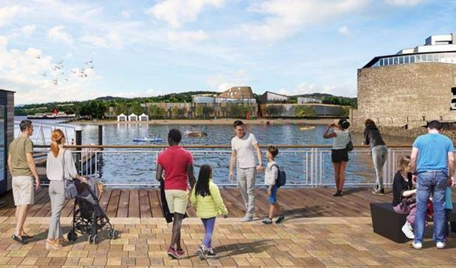

(Images have been sent to you via webcargo, Above is the view from Pierhead)

The masterplan for a new £30 million tourism investment at the foot of Loch Lomond has been submitted to Loch Lomond and the Trossachs National Park.

The development, named Lomond Banks, will transform an area of Balloch currently marked for tourism development in the local plan. The vision will include:

· A variety of family accommodation facilities, including a 60-bedroom apart-hotel, 32-bedroom budget accommodation, 131 self-catering units, 6 private houses and 15 apartments
· Facilities for visitors and the local community including a craft brewery, boat house, leisure centre and restaurants
· Landscape upgrades to public footpaths, dog walking routes and greenspaces

The project, with an anticipated completion date of 2024, expects to bring as many as 80 full time jobs, 50 part-time jobs and to 70 seasonal posts to the area.

Andy Miller, director at Lomond Banks, said: “As you can see from our artist impressions, we are fully committed to seeing Balloch become the true gateway to Loch Lomond.

“Our plans for West Riverside and Woodbank House offer an opportunity for a unique leisure based development and with Lomond Banks, Scotland will have a quality destination that respects and compliments the surrounding area.”

Scotland is frequently listed as one of the top tourism destinations in the world, with people flocking to experience its nature, landscapes, heritage and people. Loch Lomond and Balloch are already popular with day trippers and visitors from all around Scotland and the UK.

Lomond Banks will be a world class family holiday village, ensuring more people can experience everything the area has to offer in line with the vision that has been held by development agencies and the local authority since the early 1990s.

Inspired by award-winning tourism forest adventure parks and woodland accommodation already on offer in Scotland’s National Parks, Lomond Banks aims to create a quality destination, which is accessible, affordable and family oriented.

The vision will bring new life to the site’s extensive industrial past through improving biodiversity and providing active leisure activities, restaurants and retail, as well as private housing and holiday accommodation. Crucially, the masterplan balances protecting the natural woodland setting that is essential to the overall character of the development and the local area, while creating a successful visitor destination that attracts families for days out, holidays and short-breaks.

“We know that our vision for the area will add tangible value to the community and to the rest of Scotland for the next 40 years and beyond.”

Local people will have the opportunity to view and comment on the plans as part of the process. The application will be determined by The Loch Lomond and Trossachs National Park Planning & Access Committee.

To view plans visit https://www.lochlomond-trossachs.org/planning/planning-applications/major-planning-applications/west-riverside-woodbank-house/

Ends 23 April 2019

