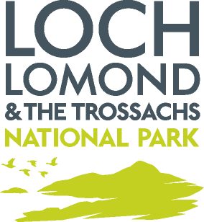

Delegated report for non-material variation (NMV)

Application Number: | 2014/0196/DET
Location: | Land At Keltie Water  Near Callander
Approved Development: | Amendment to application 2013/0225/DET for the construction of a hydro scheme.
Case Officer: | Erin Goldie

Details of the proposed non-material variations
- Retention of borrow pit.

Planning Assessment
During and after construction a borrow pit was used as a nesting site by sand martins. It is now proposed and accepted that the borrow pit will not be reinstated in order to retain this habitat for reasons of biodiversity.

Recommendation: Approve

Reason for Decision: The proposed variations are considered to be ‘non-material’ under s64 of the Act because they are deemed to have no significant adverse visual impact on the development whilst retaining habitat for a migrating species.

List of new plans

Title | Reference | Date Received
NMV Site Plan |  | 26 Oct 2017

Note: As this is a non-material variation of a planning permission under s64 of the Act, there is no change to the Informatives & Conditions attached to the original planning permission.

Signed: Amy Unitt  Development Monitoring Officer | Dated: 02.11.17

