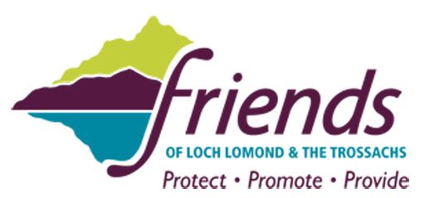

Call for bolder action on litter in Scotland’s first National Park

Friends of Loch Lomond and The Trossachs, the independent conservation and heritage charity for Scotland’s first National Park has called for bolder action to tackle the blight of litter alongside the busy A82 tourist route on Loch Lomondside and at other visitor hotspots throughout the National Park.

At the recent well-attended annual general meeting of the Friends of Loch Lomond and The Trossachs, litter was a hot topic following one of the worst years on record for accumulations of litter at beauty spots in the National Park. There was concern that the current arrangements for litter collection are poorly co-ordinated between the various agencies and fall well short of what is required in Scotland’s most popular countryside destination.

Following a lengthy discussion on litter issues and the inadequacies of the current arrangements, pleas were made for the various bodies with responsibility for litter management in the National Park to step up their efforts to combat this growing problem.

The Friends have suggested as part of a more pro-active approach to dealing with the litter problem a five point action plan should be adopted by local Councils and bodies such as the National Park Authority and Forestry Commission Scotland.

- A more joined up approach should be taken to tackling litter issues including more frequent litter clearance at busy weekends and during holiday periods;
- More and larger bins should be provided at busy locations throughout the National Park as exhortations to take litter home in isolation of other measures simply doesn’t work;
- Implementation of the same policy for the A82 on Loch Lomondside as exists along the A9 in the Cairngorms National Park where litter bins are provided in every layby and emptied regularly;
- More rigorous enforcement of litter fines as part of a wider effort to change people’s bad habits and attitudes in relation to discarding litter in the countryside and alongside road verges; and
- More hard hitting litter education campaigns on topics such as single use plastic, recycling and the impacts of irresponsible litter disposal in the National Park.

James Fraser, Chairman of the Friends of Loch Lomond and The Trossachs said: “Recent research by Keep Scotland Beautiful has confirmed Scotland is one of the dirtiest countries in Western Europe despite being voted as the most beautiful country in the world by Rough Guide readers.

“This contradiction is sadly well illustrated in Scotland’s first National Park where accumulations of litter reached an all-time high in the past year at popular beauty spots and in lay-bys along the A82.

“Working with others we have increased the number of voluntary cleans ups and the National Park Authority has improved litter clearance efforts at a number of lochside beauty spots but this has been insufficient to stem the tide.

“The time has come for much bolder action to be taken and to stop passing the buck between various agencies if we are serious about making a real difference. We all have a responsibility to ensure the National Park is a cleaner and safer place for people to enjoy and for wildlife to thrive.”

// ENDS

Photo caption: 1. Overflowing bins at Luss, by Loch Lomond; 2. Volunteers on a Friends Make a Difference Day along the A82 in October 2017.

Notes to Editors:
1. For further information contact James Fraser, Chairman of Friends of Loch Lomond and The Trossachs, on 07894 908807.
2. The Friends of Loch Lomond and the Trossachs was established in 1978 and is the only independent conservation and heritage charity working solely to protect, promote and provide projects and services for the area covered by the Loch Lomond and the Trossachs National Park.
3. The Friends has a strong membership base and is supported by a large number of individuals and companies who are passionate about caring for and celebrating the special qualities of the area.
4. The Friends often work in partnership with others, including the National Park Authority and Scottish Enterprise who support the Friends of OUR Park initiative and other projects to try and make a difference and help ensure current and future generations can enjoy Scotland's first National Park.
5. The Friends organise a series of Make a Difference Days in various parts of the National Park, which include the picking up and disposal of litter and clearance of overgrown rhododendron.

