THE ENVIRONMENTAL IMPACT ASSESSMENT (SCOTLAND) REGULATIONS 2011  SCREENING OPINION |  | 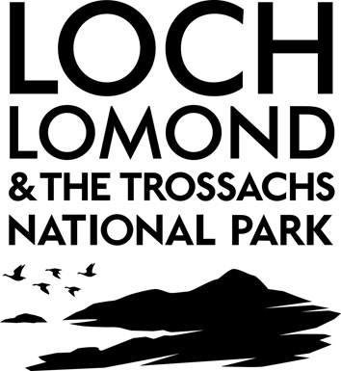

Proposal: | Erection of hotel and holiday lodge accommodation; controlled camping areas; leisure and recreational facilities; education and visitor interpretation facilities; hot food café / restaurant uses; transport infrastructure; public realm enhancements including footpaths and cycleways; viewing platform(s); appropriate ancillary uses; and landscaping and site development infrastructure including drainage and potential flood mitigation measures, SUDS measures, water supply, utilities etc.
Location: | West Riverside And Woodbank House  Balloch
Reference Number: | PSC/2017/0001

This enquiry relates to a type of development described in Schedule 2 of the Environmental Impact Assessment (Scotland) Regulations 2011.

Loch Lomond & the Trossachs National Park, as Planning Authority, hereby adopts the Screening Opinion that an Environmental Impact Assessment will be required.

In reaching this opinion the Authority has had regard to Schedule 3 of the Regulations and in particular the following:

The characteristics of the development

- Size of the development

The size of the development is considered to be more than locally significant and will include a significant degree of consequential works including transport infrastructure, landscaping, new water and power supply and waste water connection.

- Cumulation with other development

The development is within close proximity to Lomond Shores, one of the largest mixed use developments within the National Park and is in close proximity to Balloch itself.

- Use of natural resources

The scale of the development is such that there will be a significant use of natural resources including land, water, aggregates, timber and energy. This is both during construction and operation.

- Production of waste

The scale of the development is such that there will potentially be a significant amount of waste production as a result of construction and during the operation of the development.

- Pollution and nuisances

The development is in close proximity to Loch Lomond and the River Leven. There is a possible significant impact on the loch and river system due to potential pollution and sediment or man-made contaminants as a consequence of construction. This is in addition to the historic contamination of the land.

The development is in close proximity to Balloch, neighbouring residences and businesses could be impacted upon due to the potential long construction period and noise associated with the construction and operation of the development.

- Other characteristics - potential physical changes (topography, land use, changes in waterbodies etc) from construction, operation or decommissioning of the development

The development will result in a significant increase in use of 33.5ha of land and loss of woodland. The combination of proposed use will result in a significant increase in traffic to the site, this is vehicular, pedestrian, and train traffic.

The location of the development

- Location of site

The site is located within an environmentaly sensitive area, Loch Lomond and the Trossachs National Park on Loch Lomond loch shore; Woodbank House is category A listed and there are numerous listed buildings in close proximity; it is in close proximity to residential properties and businesses; there are numerous recreational activities within close proximity to the site and access rights through the site.

- Relative abundance, quality and regenerative capacity of natural resources in the area

The development could result in the loss of native woodland and impact on the ground water body where SEPA classification is ‘good’.

- Absorption capacity of the natural environment

The site is within 1.3km of Loch Lomond National Scenic Area (NSA) and development will be visible from the NSA – landscape impact is therefore a key significant impact. Depending on the extent of woodland removal there could be a potentially significant impact on the woodland. Access rights exist throughout the site and these require to be maintained. Due to the scale and nature of development, traffic congestion could have a significant impact on surrounding land uses.

Characteristics of the potential impact

The development is permanent and will have an impact on a large area (33.5ha) and will have an impact on both visitors to the National Park, residents and businesses. The proposal is complex and large scale. The construction period is likely to be long and any impacts during construction will be prolonged in terms of construction traffic, noise and pollution. The operation of the development also gives rise to potential significant environmental impact in terms of landscape impact, traffic increase and noise nuisance.

In relation to the development proposed it is considered that there is a high probability of significant impact having regard to the criteria set out in Schedule 3 of the regulations and, in particular, having regard to the scale and characteristics of the proposed land use in the location proposed, the development is an EIA development.

Signed | Julie Gray | Date | 10/04/17
 | Planning Officer
Signed | Bob Cook | Date | 13/04/17
 | DM Manager

