Loch Lomond and Trossachs Development Plan – response from Nick Kempe
The draft Development Plan was approved by the LLTNP Board on 27th April at the same meeting as the Your Park recommendations which included a proposal that the National Park should produce a Camping Development Plan. The latter has been generally welcomed in principle although there are serious concerns about the number of places being proposed, their location and their design. The lack of clarity about this is reflected in the Development Plan which has sections on camping but apart from a reference to the Your Park proposals on P15 of the Visitor Experience paper appears to have been developed in isolation from the Your Park proposals. There is an urgent for LLTNP to join up the two.
- Terminology
While the two documents both refer to “formal campsites” they use significantly terminology to describe other camping provision, particularly in respect of the new types of camping provision proposed in Your Park. The Your Park recommendations paper referred to low cost campsites with “basic” facilities (para 5.4) and that camping would be allowed under permit in places with “limited” or no facilities. It did not define what “basic” and “limited” facilities were or the differences between them. The lack of clarity is increased further on (Para 5.11) where the recommendations states “The development of basic low cost campsites will provide opportunities for visitors looking for a slightly more managed facility” but goes on to say the National Park “will also develop a small number of seasonal sites of similar style to those at Sallochy and Inchcailloch”. It is unclear if Sallochy is regarded as a “basic” campsite or not. The Draft Development Plan, in its draft Visitor Experience Planning Guidance (P16) categorises campsites as formal, semi-formal and informal. Informal sites are described as temporary, seasonal, having no lighting, water or drainage but they may have temporary or composting toilets while semi informal sites are described as the same as informal ones except they may have low level lighting. How this categorisation relates to the description of basic and limited facilitities in the Your Park recommendations paper is totally unclear and in planning terms it seems that there will be NO water provided at informal or semi-formal campsites which did not appear to be the intention of the Your Park paper which allowed for a range of facilities.
I therefore wish to object to the categorisation of types of camping in the Development Plan as being incompatible and unhelpful in terms of the objectives set out in the Your Park proposals which suggest the Park’s Camping Development Plan should allow for a range of camping provision.
- Visitor Experience Planning Guidance – caravan sites
The Guidance refers to existing static caravan sites (P9) but makes no reference to the fact some of these still have a small number of places for touring caravans, an example being the site at the SE corner of Loch Earn. This section states the National Park will not allow existing static caravan sites to convert to residential accommodation, saying it wishes to retain places, but makes no reference to maintaining or creating more places for touring vans and tents in these caravan parks.
This is likely to result in further loss of touring places and therefore I wish to object.
While I support the commitment of the National Park not to allow static caravans to chan and no mention this. Want retain existing caravan parks P9 says some caravan parks in too remote locations for residential housing – really?
- Visitor Experience Planning Guidance - Locations of new campsites.
The Guidance on Visitor Experience states “We are likely to support tourism development within towns, villages and land allocated for tourism” and “We are likely to support small scale tourism development with good access to the existing network of paths, infrastructure or visitor facilities the red shaded areas on maps” (P11). It goes on to state “an informal touring caravan or campsite would be likely to be considered small scale” (P12). Apart from an area around Glenbranter and between Crianlarich and Tydrum all the red shaded areas are on the east side of the National Park and while covering the Trossachs lochs do NOT cover west Loch Lomond, east Loch Lomond or Loch Long. So, what this means in terms of the Local Development Plan as worded is the LLTNP is NOT supporting new “informal” campsites in the west side of the National Park. This is totally wrong and I wish to object. The National Park Authority needs to allow small scale sites in the west of the National Park area.
It is not clear how this position fits with the statement that follows (P15): “THE NPPP is particularly supportive of camping provision in East and West Loch Lomond and the Trossachs”. In view of the statements on P11-12 it appears this only refers to “formal” campsites but this is unclear. That this is so is suggested by the statement that “This would need to be in the right locations with appropriate access, parking and no adverse environmental impacts including visual and landscape impacts”.
I therefore object to the Development Plan unless it is made very clear that the support for additional campsites throughout the National Park refers to all types of campsite, formal, semi-formal or informal.
“There is growing demand for camping and overnight motorhome provision in the Park and we consider that camping and caravan sites provides valuable inexpensive holiday accommodation in the Park” P15
The end of Page 15 refers the reader to the Design Guidance document “for more information on the siting of campsites” but that contains NO information on the siting of campsites, only campsite design.
I object to the Development Plan as it fails to give sufficient guidance on siting of campsites, whether formal, semi-formal or informal. The guidance on siting should encourage provision of campsites around settlements which are popular tourist destinations.
- Visitor Experience Planning Guidance - Toilets
Toilets are covered in the Guidance on the Visitor Experience, Page 21, in a short section on toilets and parking. No assessment or reference is given on the demand for public toilets in the National Park or the issues that arise as a consequence despite this being the number one concern in visitor surveys. The statement supports developments in what it calls settlements and key recreational sites. It is unclear whether popular sites for camping at present are regarded as key recreational sites or not and the absence of maps for areas outwith settlements does not help with this. It is therefore unclear if the National Park still supports the development of toilet provision which was set out in its own 5 Lochs Management Plan. There is no mention of the planning framework or what the National Park’s policy is in respect of temporary toilet provision to meet peak demand – in contrast to camping where P15 usefully sets out the legal framework for camp and caravan sites.
I wish to object to this section of the Local Development as being totally inadequate and failing to reference the Park’s own Five Lochs Management Plan which included several proposals to include toilet facilities at specific sites.
- Planning Conditions.
The Visitor Experience Guidance Page P26 give examples planning conditions to accompany planning permission. These include conditions specifying the maximum places for tents, caravans, yurt and that pods and requirements that places will not be changed from say camping to caravans. The restriction on change of type of place is to be welcomed as it could help stop the loss of camping places in the National Park.
Also included in the conditions is a requirement that seasonal/informal camping sites can only be used 1 March to 31st October and for a maximum stay of four weeks. No rationale is given for the seasonal restriction and it makes no sense in terms of the Park’s other objectives. While numbers are much lower, there are people who want to camp over the winter and keeping facilities such as toilets open will help reduce the type of impact the National Park raised such a fuss about in the Your Park consultation. Its unclear from the letter to Ministers accompanying the Your Park Proposals whether the LLTNP has decided that ALL the new camping places it is proposing should be seasonal and whether the Development Plan is also saying this.
I therefore wish to object to proposal from the Park for seasonal restrictions to be applied to informal camping sites
- Specific locations
The Development Plan includes site maps for towns and villages “which we have allocated for specific development uses such as housing, economic development and visitor experience” (SECTION 3.2). The LLTNP has developed a set of icons to illustrate uses – these do NOT include camping. It may be because of this there are no proposals in the plan for new campsites around settlements. Some examples of where campsites are needed are given below. I wish to object to the failure of the Local Development Plan to illustrate any plans for new campsites in the section of the plan that deals with Places.
Head of Loch Long
There is no new camping proposed at Arrochar but instead 12 new homes are shown on the Caravan Park (a further loss of capacity) and 26 homes at Succoth and the Torpedo range (pp52-54). The Ben Arthur development though being described as part of the Visitor Experience offers no space for camping, an opportunity lost. The context for this is that the magnificent camping site at Ardgarten was developed into a chalet park and does not any longer make provision for camping or touring caravans or motor homes (with planning granted by the National Park) . The SYHA hostel, originally endowed to permit young people to enjoy the The Argyll Forest Park was sold off and developed into a luxury hotel. There is now just one small facility, the Glen Loin campsite, left and that is not well signposted so many people unaware of its existence. The result is that campervans etc use the parking area at the head of the Loch. The overall outcome is the Park through its planning framework has failed to do anything to make up the loss of places and excluded the possibility of a campsite around the head of Loch Long despite Arrochar being one of the most popular destinations in the National Park for hillwalkers and climbers. The proposal to ban camping from around the rest of the head of the loch is risible, as there is almost no campable ground left apart from the car parking areas at the head of the Loch.
I wish to object to the lack of camping provision around Loch Long
Balloch
No proposals are shown on the site plan. This is not a popular area for camping, although some respondents to the Your Park consultation referred to people camping in the country parks at Balloch. However, if the National Park is serious about promoting the John Muir Way as a cross country trail, campsites are needed along it and Balloch is one of the places where a small camping facility should be situated
I wish to object to the lack of camping provision at Balloch for walkers of the John Muir Way.

Balmaha
The Development Plan refers to a number of undeveloped sites and potential for future development but makes no reference to camping. Yet Balmaha is a key stopping off point for walkers of the West Highland Way and if the proposals of the Park to extend the proposed Management Zones are extended there will be absolutely nowhere to camp close to the village. Organisations like Friends of Loch Lomond and Trossachs in the Your Park consultation argued there was a need for a campsite at Balmaha. This has been ignored by the NPA who could use its compulsory purchase powers to create a campsite there in the public interest if no landowner was prepared to co-operate.
I wish to object to the lack of camping provision at Balmaha and the NPA’s promotion of other use categories in preference to camping
Lochearnhead
There is considerable space around the village that could be used for campsites and very high demand as there are no public campsites around the Loch.
I wish to object to the lack of camping provision around Lochearnhead given the demand for camping around the loch which the National Park wishes to ban.

- Design Guidance – Boundaries (P42).
The section of the Design Guidance on boundaries rightly states that boundary barriers should be designed in accordance with the character of the National Park. There is NO reference to deer fencing, which although sometimes a permitted development, can be put up around houses in settlements or for non-agricultural or forestry purposes. The need for this is illustrated by the example below, the new boundary fence for Loch Venachar House, currently the residence of the convener of the National Park Authority, which appears to have replaced the wall which was included in the original site plans for the adjacent car park (Five Lochs Visitor Management Plan):
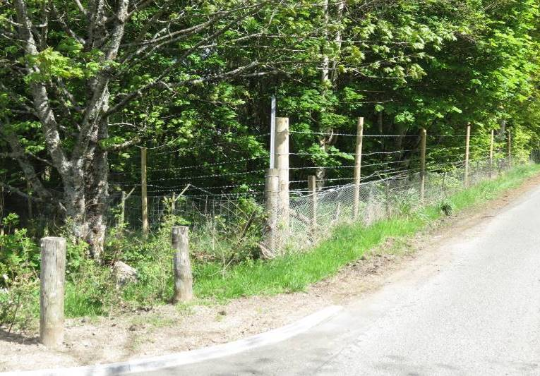
To support the Park’s access objectives the section on boundaries should include a statement about the importance of boundaries being compatible with access rights, provisions of gates and styles etc.
I wish to object to the section in the Site Guidance on Boundaries in the Local Development Plan as it should refer to deer fencing (undesirable and unacceptable for residential properties) and access rights.
- Design Guidance - Caravan and Campsites (P71)
As pointed out above this contains no guidance on the siting of campsites. It should do. There is some generally sound advice in this section but this is not related to the categories of formal, semi formal and informal campsites for which there are likely to be different design considerations. This needs to be made clearer. There is no mention of the impacts of tents on ground vegetation which is strange given Your Park makes considerable play of impact camping on vegetation and how campsites might avoid this given that they tend to concentrate use on particular pitches.
There has been a failure to join up the design guidance in the draft Development Plan with the Your Park proposals. LLTNP’s illustrative campsite design, which accompanied its letter to Ministers, shows a campsite built on a hillside with wooden platforms. This appears to have been done by someone who has little experience of camping and is hardly a low key development. How campers will put in pegs to platforms is not shown and there are a number of health and safety issues relating to ensuring the platforms remain in sound condition, have sufficient means to secure tents etc. The campsite created at Sallochy is a much better example of the type of facility needed and according to information provided by the LLTNP is extremely well used.
I object to the Design Guidance as it should include guidance on siting, as stated elsewhere in the Plan, and clarify the design considerations of the different types of campsites
The LLTNP’s thinking about campsite design appears to be at a very early stage despite its experience at Sallochy and Loch Lubnaig where there have been considerable challenges and costs associated with providing electricity and flushing toilets.

Nick Kempe
23 Queen Square
Glasgow
G41 2BG
0141-423-9011

Appendix 7 accompanying letter to Ministers

